CP1856 Programming with Python

Project Report

Austin Perry & Shangyun Wang

Video Library Management System

Introduction

This Video Library Management System allows users to manage their video collections. Users can add, edit, delete, and display video information and search for videos based on various criteria.

Features

1. Add a new video

2. Edit video information

3. Delete a video

4. Display all videos

5. Display detailed video information

6. Search for videos by criteria

7. Exit the system

Main Modules

• main.py: Entry point of the program, manages the menu and user input.

• add_video.py: Adds a new video.

• edit_video.py: Edits existing video information.

• DeleteVideo.py: Deletes a video.

• DisplayVideos.py: Displays all videos.

• VideoInfo.py: Displays detailed information of a video.

• list_by_criteria.py: Searches for videos based on criteria.

• ReadWrite.py: Handles reading and writing video data.

Block Diagram

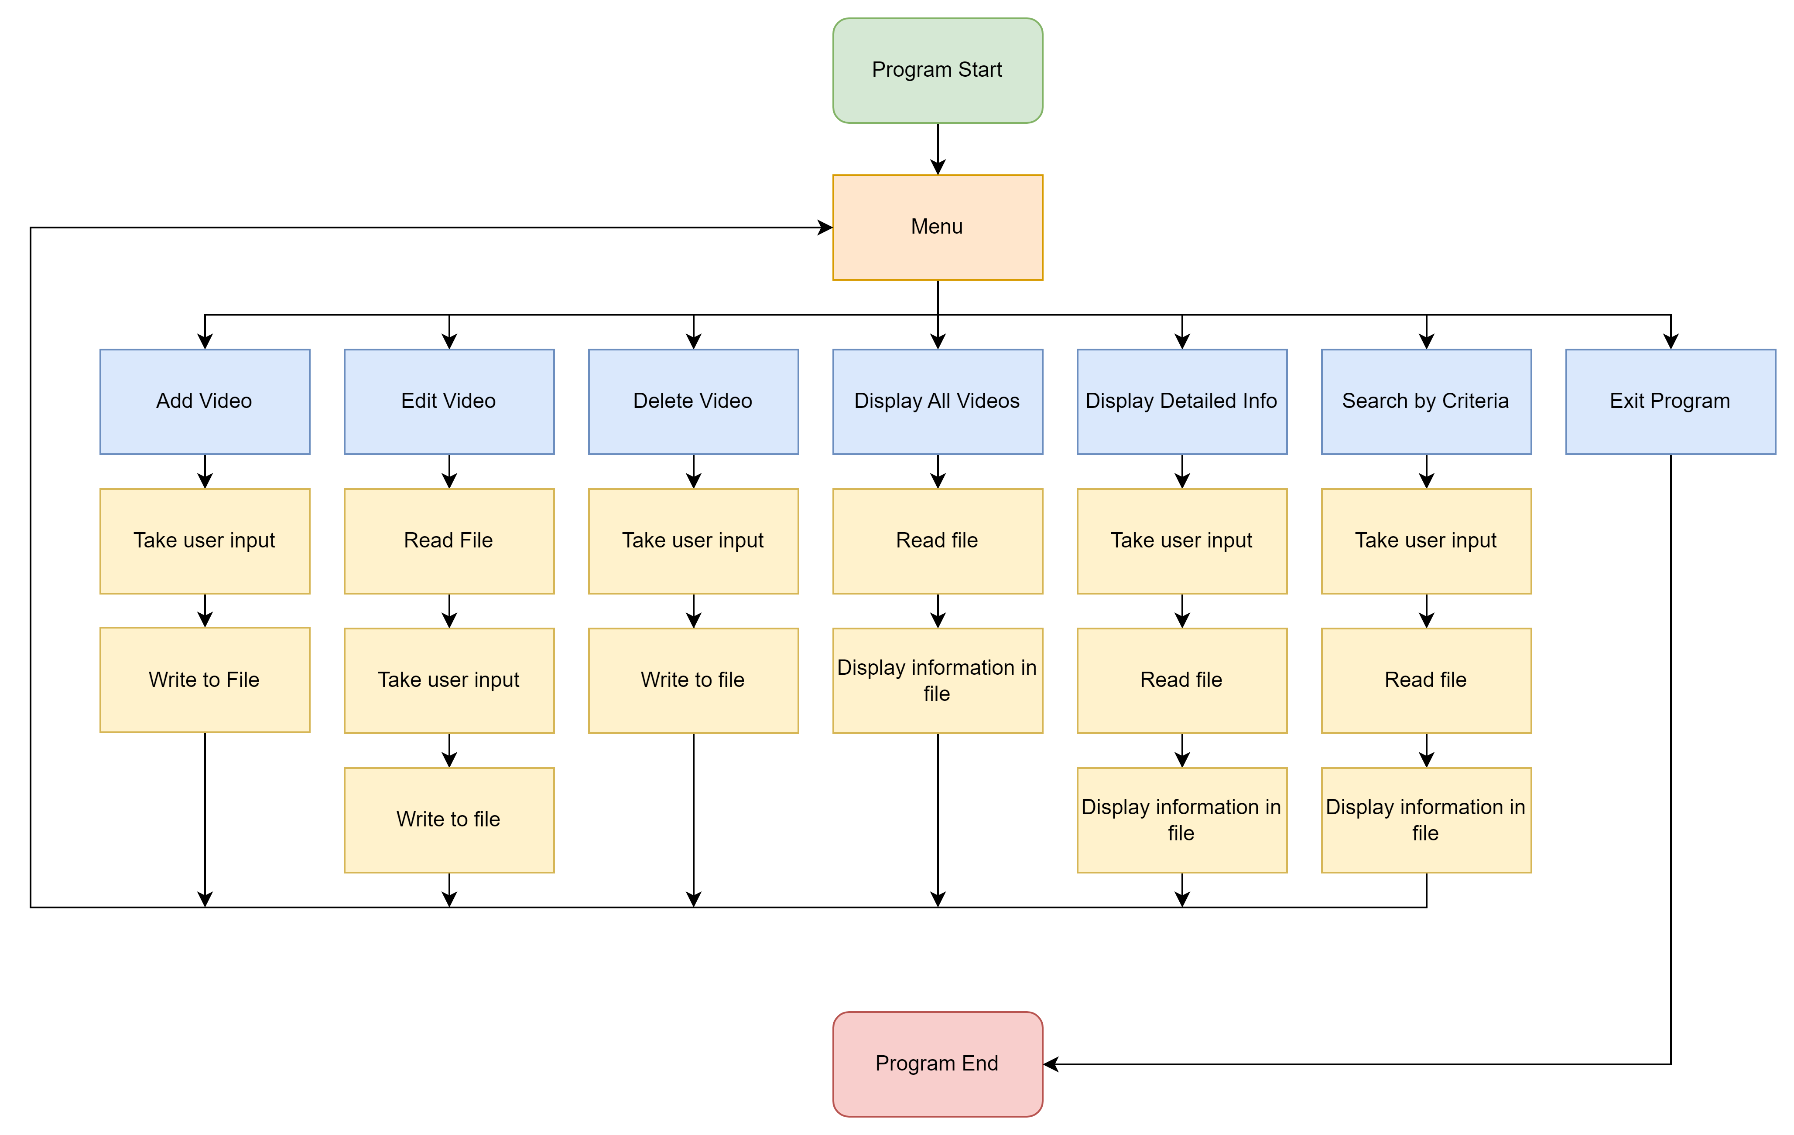

Project Flow Explanation

1. Display Main Menu: main.py calls display_menu function to display menu options and waits for user choice.

2. Handle User Choice:

• If the user chooses to add a new video, it calls add_video.py.

• If the user chooses to edit a video, it calls edit_video.py.

• If the user chooses to delete a video, it calls DeleteVideo.py.

• If the user chooses to display all videos, it calls DisplayVideos.py.

• If the user chooses to display detailed video information, it calls VideoInfo.py.

• If the user chooses to search for videos by criteria, it calls list_by_criteria.py.

• If the user chooses to exit the system, the flow breaks.

3. Read/Write Video Data: All modules that handle video data operations utilize ReadWrite.py to read and write data to the CSV file.